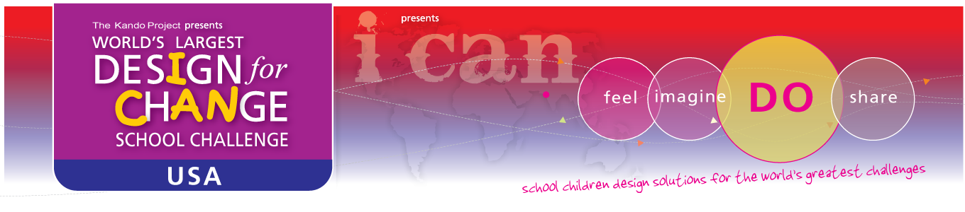

**TEACHERS**

Definition: Some of the hardest working people in the world. They not only teach us valuable skills, they inspire us, they are our mentors they are our role models.

**WORLD’S LARGEST CHILDREN’S CHALLENGE!**

Thank you for responding to our call to participate in the Design for Change school Challenge, a global initiative empowering children to say I CAN instead of Can I? As part of global movement of over 35 countries, you are now part of the **LARGEST** school challenge the world has ever seen!!

**SO NOW WHAT?**

Now that you have become familiar with the Design for Change process of Feel, Imagine, Do, Share, you must be wondering, what’s next? Below are a few simple steps to which you can follow to start your project today!

1. Read the Essential Questions Guide
2. Read the Getting Started Guide
3. Read the Top Ten Tips for Teachers
4. Fill out the Registration Form online

**WE NEED YOU!**

We, the Design for Change team are here to support your every effort as you work through your Design for Change project. The success of your project is largely dependent on your ability to channel the passion of your students into a project they not only feel passionate about, but one that will have wide spread societal impact.

We thank you for taking on this challenge and we promise an unforgettable experience!

Please visit [www.designforchange.us](http://www.designforchange.us) for more details or email us at info@designforchange.us

Together, let’s show the world what children are capable of!

Sincerely,

The Design for Change USA Team